TOP COPPER

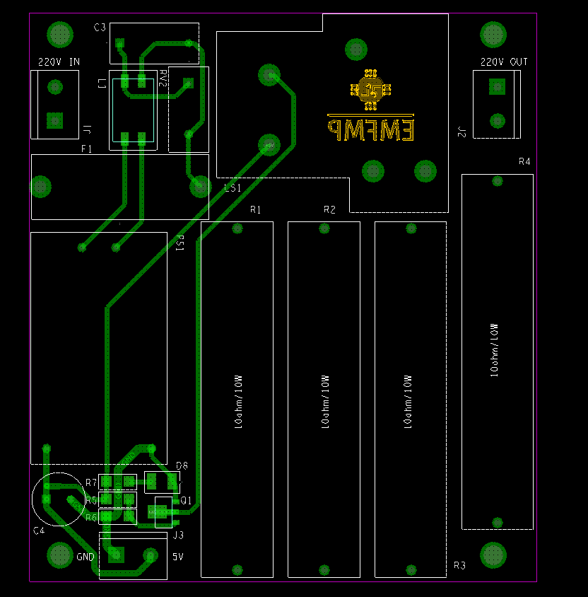

BOTTOM COPPER

